**A PROJECT REPORT**

**on**

**Submitted in Partial fulfillment for the award of degree of**

**Bachelor of Technology (Computer Science and Engineering / Data Science / Artificial Intelligence)**



|  |  |
| --- | --- |
| Mentor | Submitted By :Chetan Singh |
| Mr./Ms./ Dr. Megha Gupta |  |
| CSE, SKIT | Roll No. 23ESKCA031 |
|  |  |
| Coordinator: | Head of Department: |
| Mr. Manish Bhardwaj | Dr. Mukesh Kumar Gupta |
| CSE,SKIT | CSE, SKIT |

**DEPARTMENT OF COOMPUTER SCIENCE & ENGINEERING**

**SWAMI KESHVANAND INSTITUTE OF TECHNOLOGY, MANAGEMENT AND GRAMOTHAN**

**RAMNAGARIA (JAGATPURA), JAIPUR-302017**

**September, 2022**

**ACKNOWLEDGEMENT**

It is my pleasure to be indebted to various people, who directly or indirectly contributed in the development of proposed work and who influenced my thinking, behavior, and acts during the course of study.

I express my sincere gratitude to **Dr. Mukesh Kumar Gupta/ Dr. Anil Choudhary,** Professor and Head, **Department of Computer Science and Engineering**/ **Department of Information Technology** for providing me an opportunity to undergo In-house Internship programme at SKIT, Jaipur. I am thankful to **Mr. Manish Bhardwaj/ Ms. Surbhi Sharma**, Coordinator (II year In-house internship 2022-23), for his support, cooperation and motivation provided during the internship for constant inspiration, presence and blessings. I also extend my sincere appreciation to **Mr. Manish Bhardwaj, Mr. Sumit Kumar, Mr. Pawan Kumar Patidar, Ms. Mamta Sakpal, Mr. Loveleen Kumar, Mr. Madhav Khatri, Ms. Surbhi Sharma and Ms. Priyanka Sharma** who helped me in learning HTML, CSS, JAVASCRIPT, PHP and SQL.

I also extend my I also extend my sincere appreciation to **< Lab incharge during internship>** who flourished and helped me in lab sessions conducted during internship.

I also extend my sincere appreciation to **< ITR faculty>** who provided his valuable suggestions and precious time in accomplishing my report.

At last I must express my sincere heartfelt gratitude to all the staff members of Department **of Computer Science and Engineering**/ **Department of Information Technology**, who helped me directly or indirectly during this course of work.

**CHETAN SINGH**

**23ESKCA031**

Table of Contents

1. Introduction

1.1 Problem Identification 1

1.2 Project Scope **.**

1.3 Intended Users 1

1.4 Tools and Technologies to be used 1

2. Methodology

2.1 software model used ………………………………………………………………………………….

3. Dependencies

3.1 Hardware Requirements..……………………………………………………………………2

3.2 Software Requirements……………………….……………………………………………….....2

4. Implementation and Testing

4.1 Flow Chart………………………………………………………………………………………...4

4.2 Database snapshot………………………………………………………………………………...4

4.3 Code/project snipets……………………………………………………………………………………….4

5. Conclusion and Future Scope

References

**CHAPTER 1**

**INTRODUCTION**

* 1. **Problem Identification**

This project aims to address the need for a well-structured, responsive website template that incorporates HTML, CSS, and JavaScript

* 1. **Project Scope**

The solution is intended for developers looking to quickly set up a project with basic front-end technologies.

* 1. **Intended Users**

The users include website developers, designers, and end-users who interact with the website.

* 1. **Tools and Technologies**

HTML, CSS, JavaScript were the core technologies used in the development of the website.

**CHAPTER 2**

**METHODOLOGY**

* 1. **Software Model Used**

The development of this project followed an **Agile methodology** to ensure flexibility and adaptability throughout the process. The Agile model allowed for iterative development, where the project was built in small, manageable increments. Each increment focused on a specific feature or aspect of the website, such as:

1. **Design and Layout**:
   * The initial phase involved designing the basic structure of the website using **HTML**. This included defining the layout, navigation, and content sections.
2. **Styling and Responsiveness**:
   * In the second phase, **CSS** was used to style the website. Emphasis was placed on creating a responsive design that adapts to different screen sizes, ensuring that the website works well on both desktops and mobile devices.
3. **Interactivity**:
   * **JavaScript** was introduced to add interactive elements to the website, such as form validations, dynamic content loading, and other user-triggered actions.
4. **Continuous Testing and Debugging**:
   * After each development phase, the website was tested for errors, responsiveness, and cross-browser compatibility. Any bugs or issues identified were promptly fixed.
5. **User Feedback**:
   * Feedback was gathered continuously during the development process, allowing for adjustments and improvements in real-time.

**CHAPTER 3**

**DEPENDENCIES**

* 1. **Hardware Requirements**

Basic computer with internet connection

**3.2 Software Requirements**

Any text editor or IDE, a web browser

**CHAPTER 4**

**IMPLEMENTATION AND TESTING**

**4.1 Flow Chart**

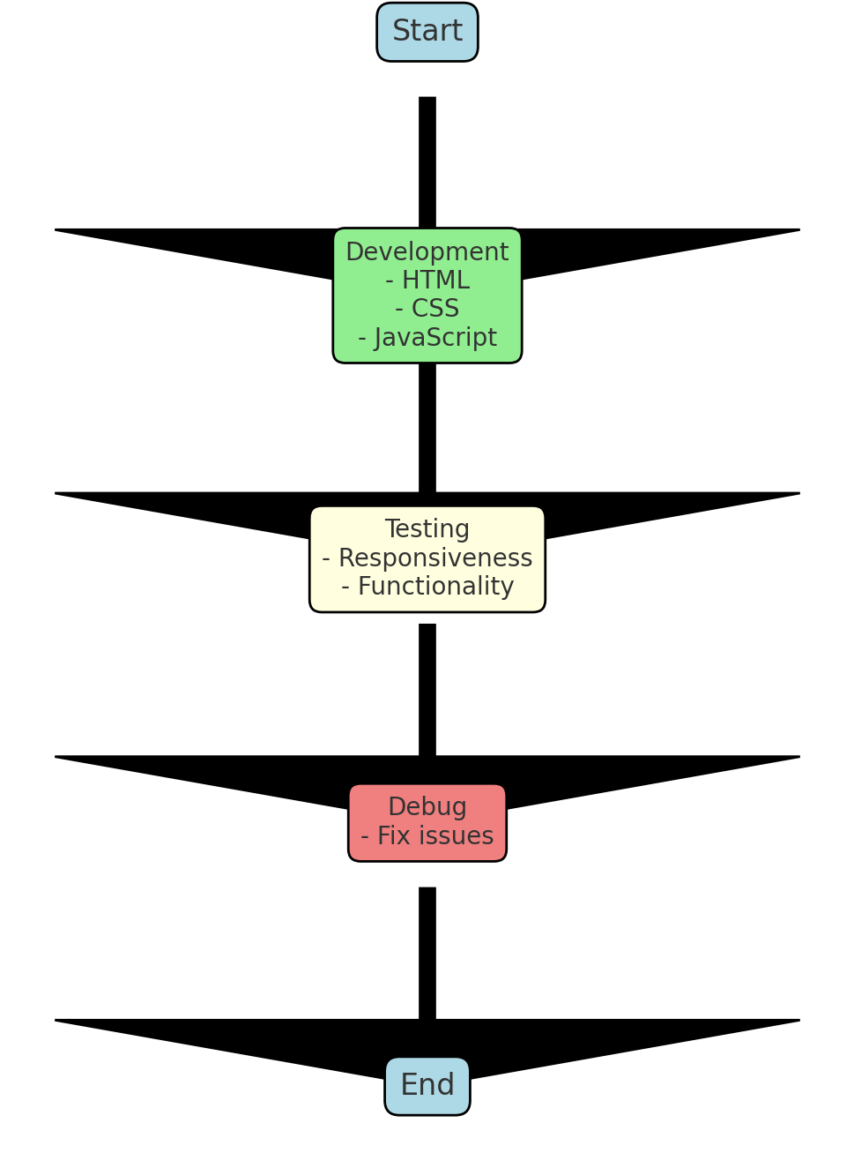

**4.2 Database Snapshots and details**

No database was used in this project

**4.3 Code and Project snapshots**

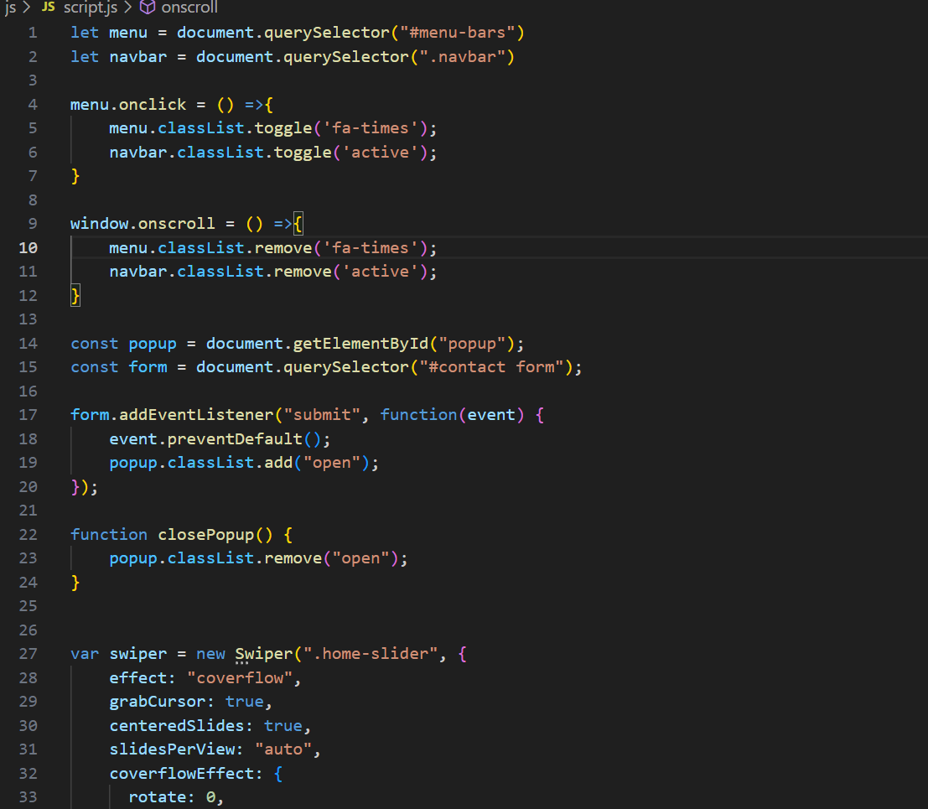

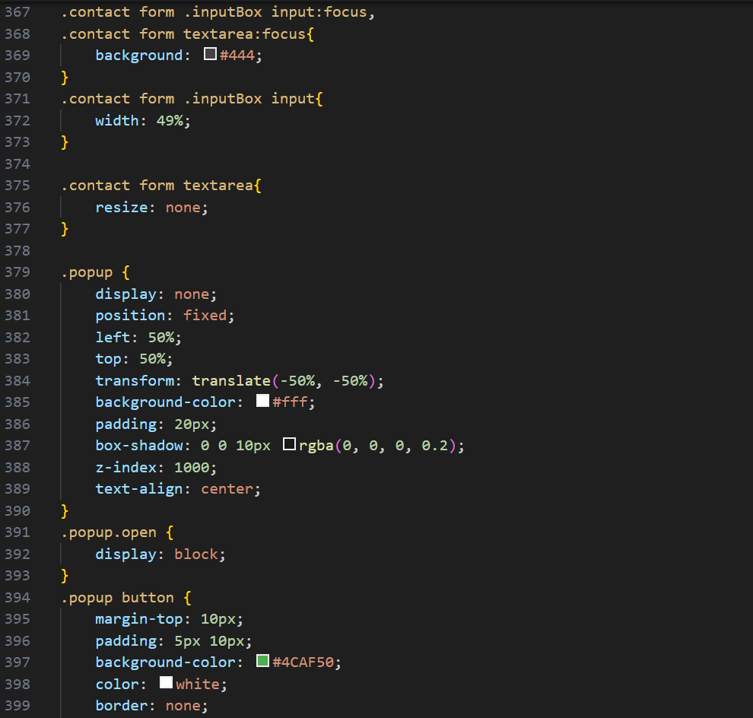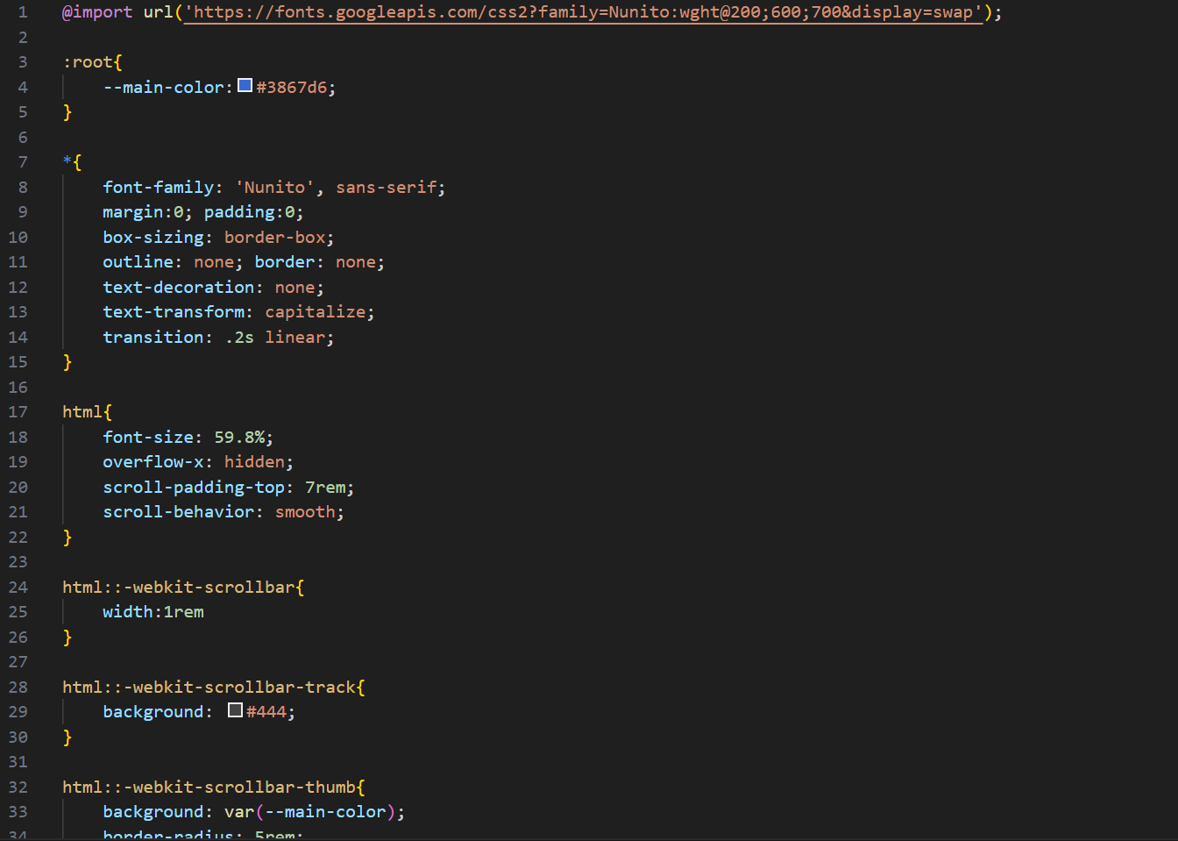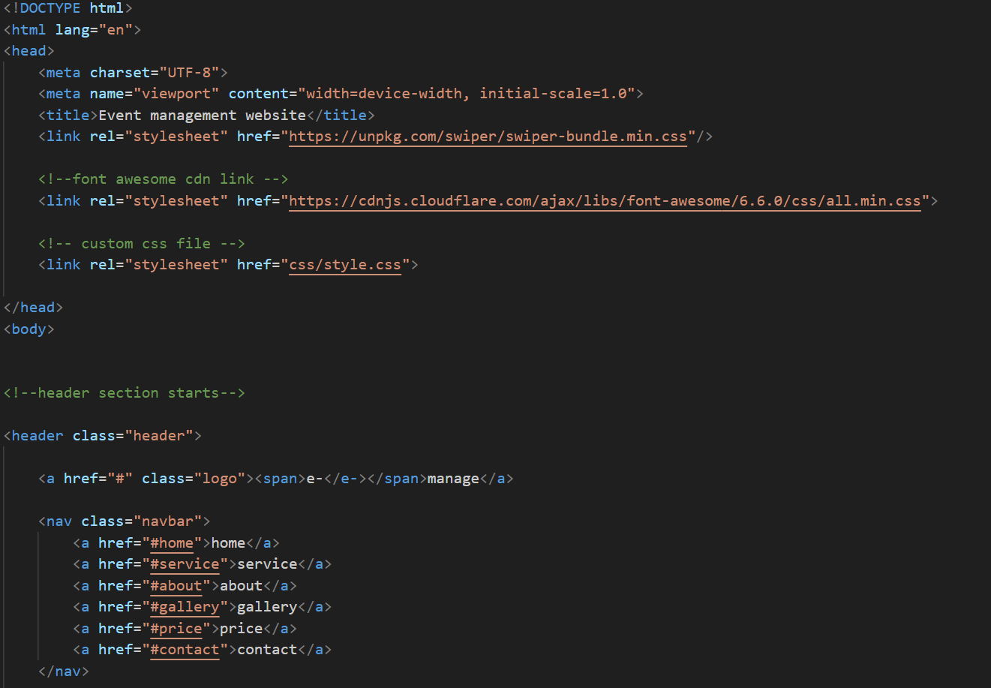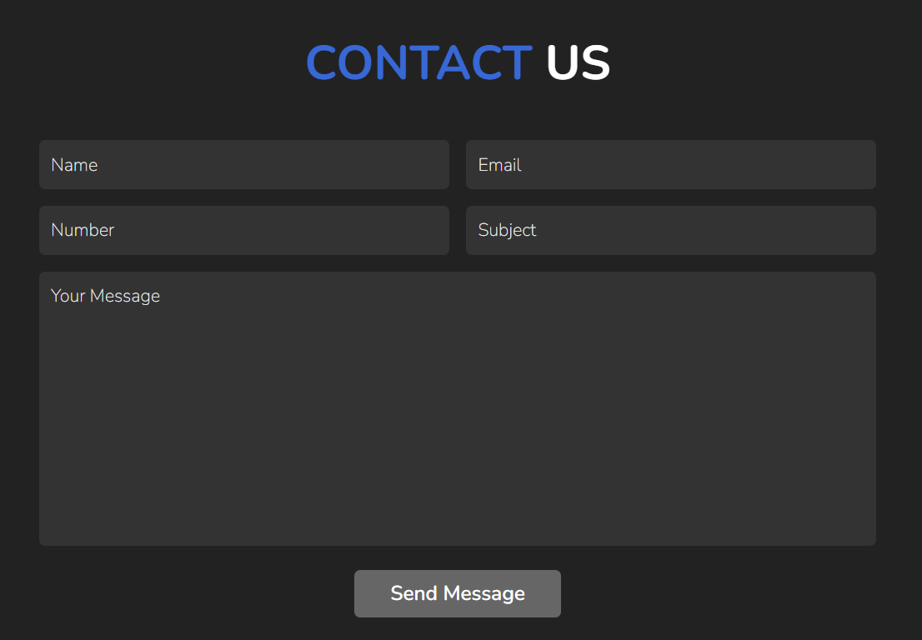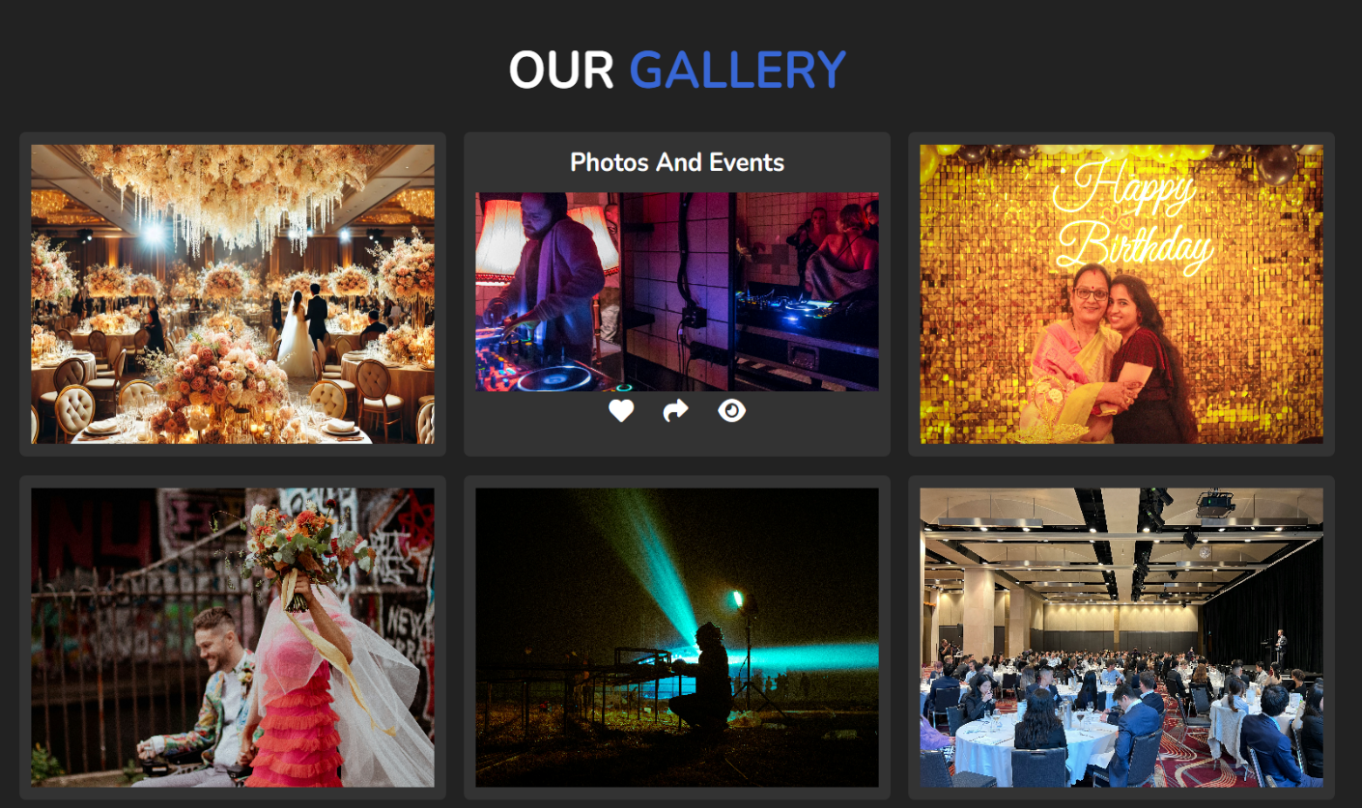

**CHAPTER 5**

**CONCLUSION AND FUTURE SCOPE**

This project successfully developed a responsive website template using front-end technologies. Future work could include adding more dynamic features like backend integration and user authentication. Also we can add some database in it and a login page for admins and customers.

**REFERENCES**

1. HTML, CSS for layout and styling.
2. JavaScript for interactive features.
3. Swiper.js library for responsive image sliders